In Java, the PriorityQueue class is commonly used to implement a Min-Heap or a Max-Heap. By default, PriorityQueue implements a Min-Heap. To implement a Max-Heap, you can use a custom comparator.

Min-Heap Example
A Min-Heap is a binary heap where the smallest element is always at the root.
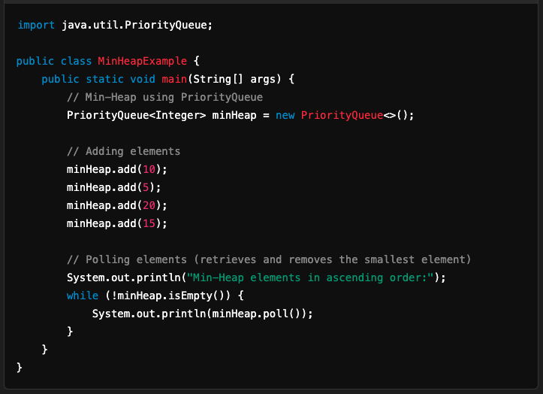

Max-Heap Example
A Max-Heap is a binary heap where the largest element is always at the root. You can achieve this by using a custom comparator.
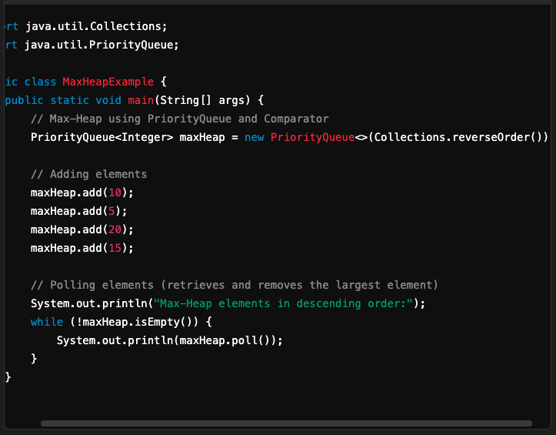

Explanation:
- Min-Heap:
  - By default, PriorityQueue uses the natural ordering of elements (Comparable) to implement a Min-Heap.
  - The smallest element is always removed first.
- Max-Heap:
  - A custom comparator (e.g., Collections.reverseOrder()) is used to reverse the natural ordering, making the largest element appear at the root.

Notes:
- You can use PriorityQueue with objects by providing a custom comparator. For instance, if you have a class with multiple fields, you can sort based on a specific field.
- PriorityQueue does not support null elements.

